Safeguarding Team

If you have any concerns of a safeguarding nature, please do not hesitate to contact a member of the safeguarding team, who will be happy to listen to any concerns. Thank you.

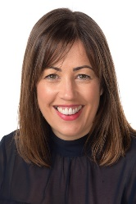

Senior Designated Safeguarding Lead Designated Safeguarding Lead
-Mrs Caroline Stewart -Mr Aaron McDonald

Designated Safeguarding Lead Designated Safeguarding Lead Designated Safeguarding Lead
-Miss Amy Latham - Mrs Linda French-Eaton - Mrs Emily Dell

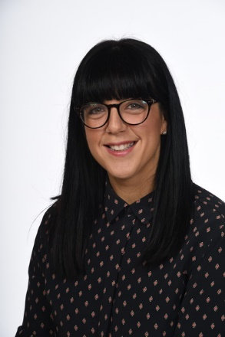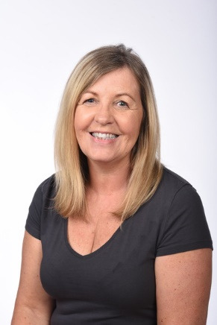

Designated Safeguarding Lead Designated Safeguarding Lead
-Mrs Rosie Godfrey -Mrs Diane Wellington

