

**Safeguarding Team**

If you have any concerns of a safeguarding nature, please do not hesitate to contact a member of the safeguarding team, who will be happy to listen to any concerns. Thank you.

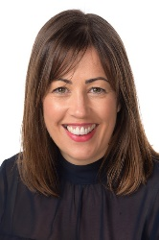

Senior Designated Designated Safeguarding Designated Safeguarding

Safeguarding Lead Lead Lead

-Mrs Caroline Stewart -Mrs Emily Dell Mrs Linda French-Eaton



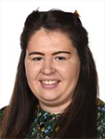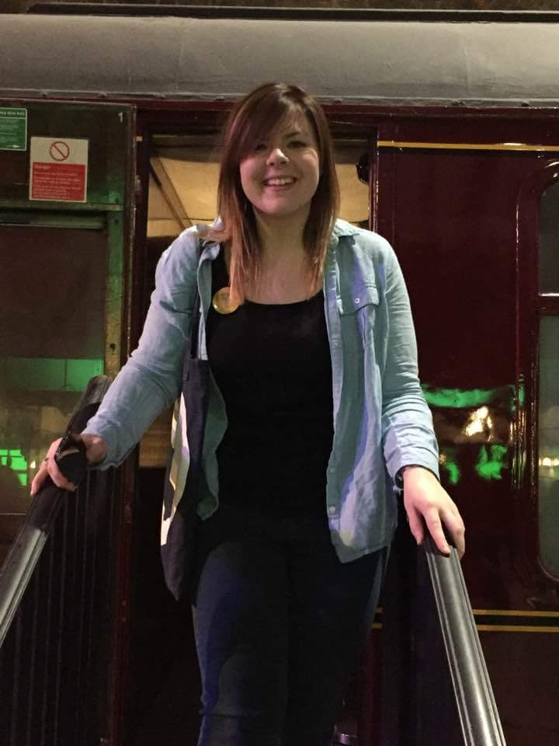

Designated Safeguarding Designated Safeguarding Designated Safeguarding

Lead Lead Lead

Mrs Ella Websdale Mrs Nara Petrosian Miss Lucy Randall

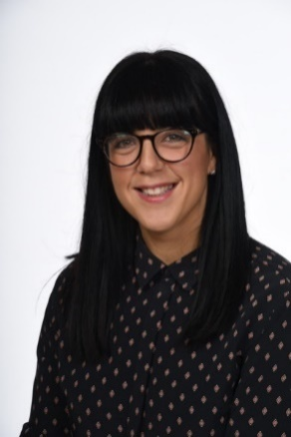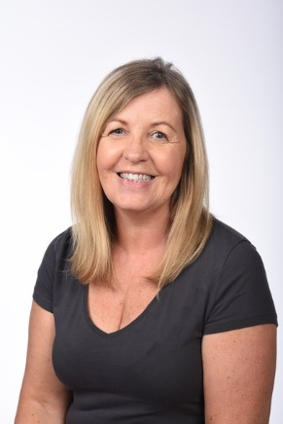

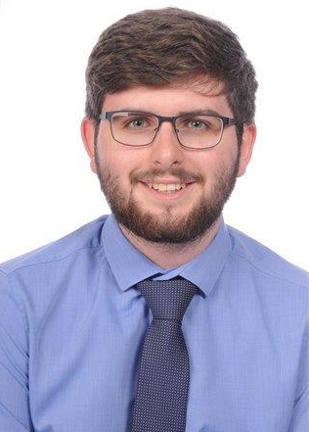

Designated Safeguarding Designated Safeguarding Designated Safeguarding Lead Lead Lead

Mr Trafford Ayres Mrs Rosie Godfrey Mrs Diane Wellington